Passively Monitoring a Wireless Network
Grand Canyon University, College of Science, Technology, and Engineering
Professor Lisa Gasko
ITT-370, Wireless Networks
Liela Pressley
11/09/2023
- I first connected to my Starbucks public network.
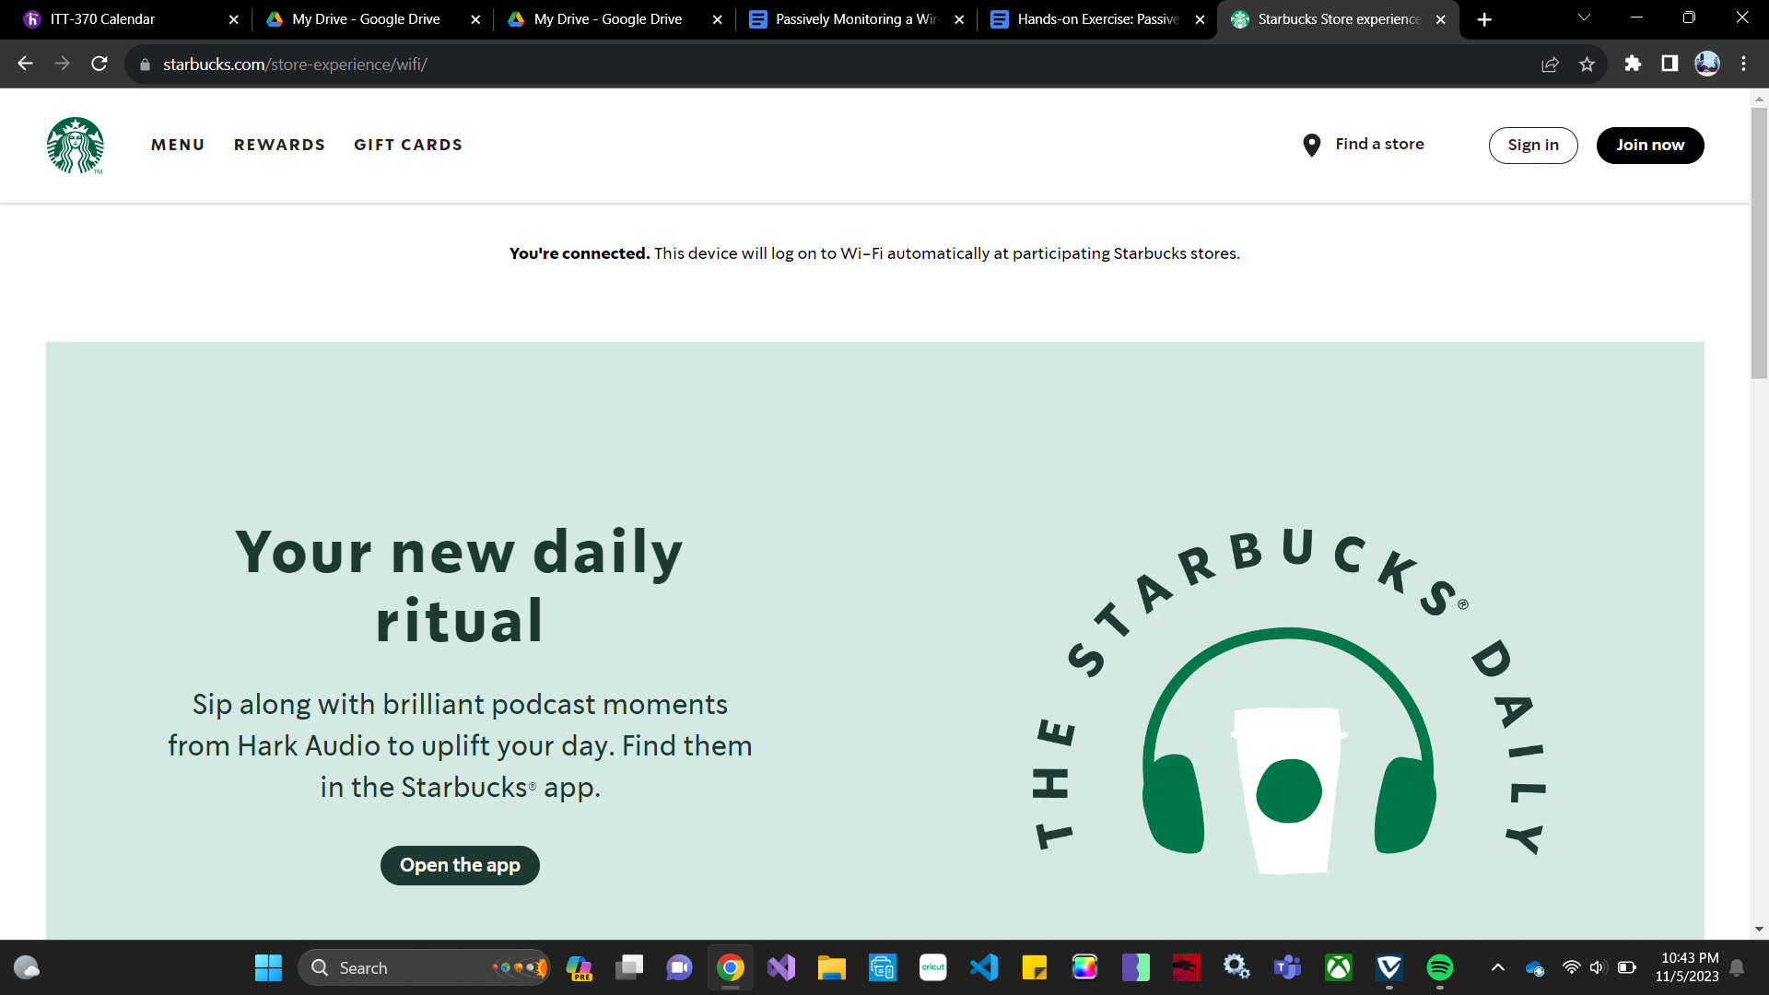
2. I then downloaded and installed Wireshark and opened the software. It then requested me to select the network I wanted to monitor and I selected Wi-Fi2 after referring to my settings which explained which network adapter is connected to which network (did not provide the screenshot for security purposes). Because I had multiple webpages open prior to starting wireshark and the various devices that were utilizing this public network the list of packages that were appearing created a continuous and endless list.
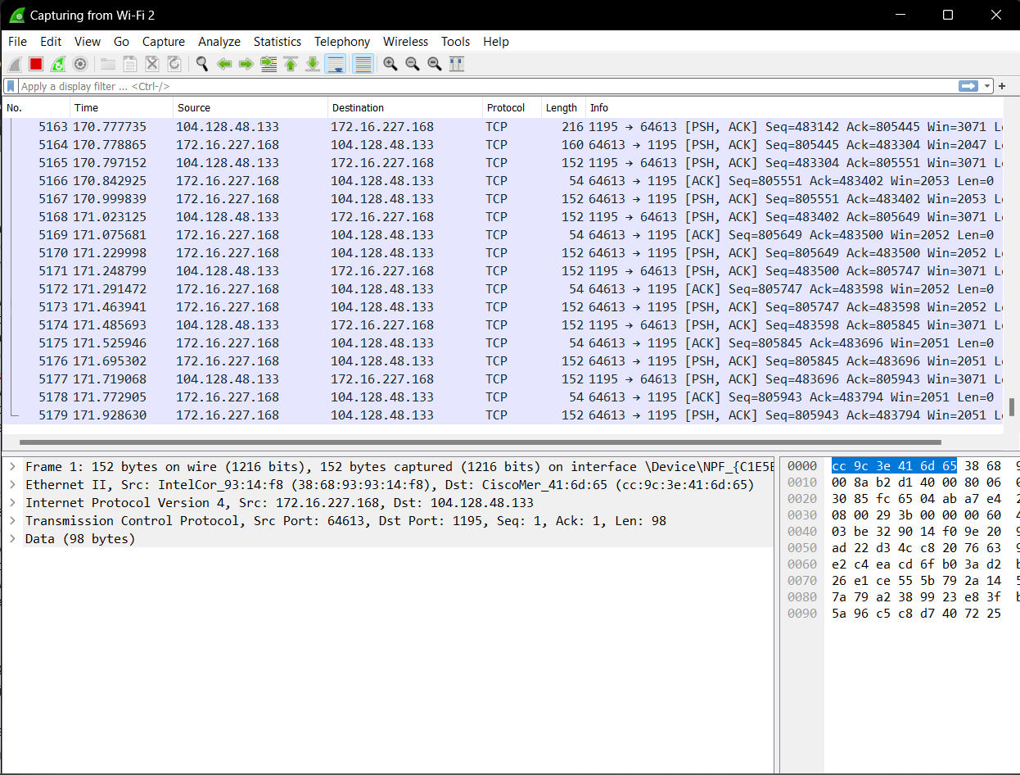
3.I scrolled to the top and wanted to confirm the interaction between my computer and the network by confirming the IP addresses of both. I was able to confirm the IP address of Starbucks using my network settings (172.16.227.168) on my computer (beginning with 104….).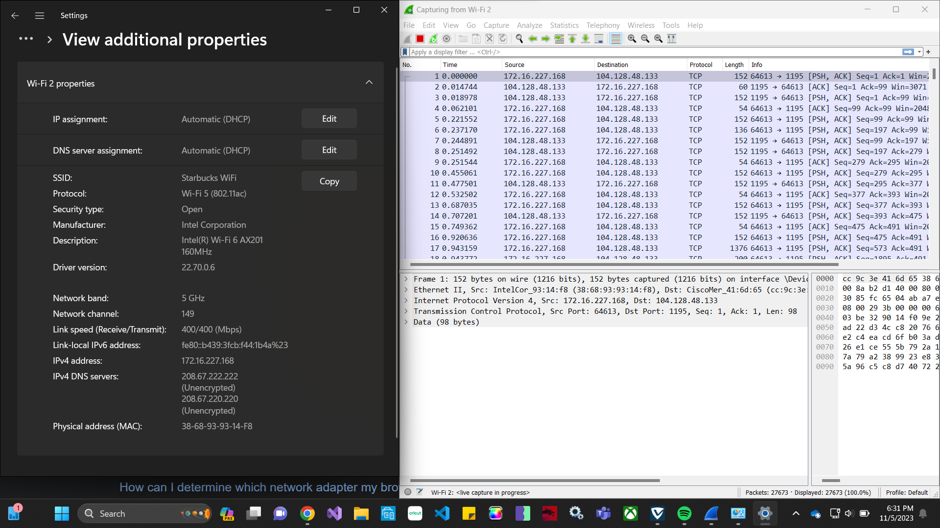
4.I wasn’t using a virtual machine so I didn’t want to risk visiting unsecured sites as I am due to renew my antivirus software. But what I did notice once I started to visit sites on my personal network that I was still able to view a decent amount of information about other devices that were connected to my network such as smart tvs. As shown below I was able to see not only my LG tb but the activity and requests that it was making within my network for different services.
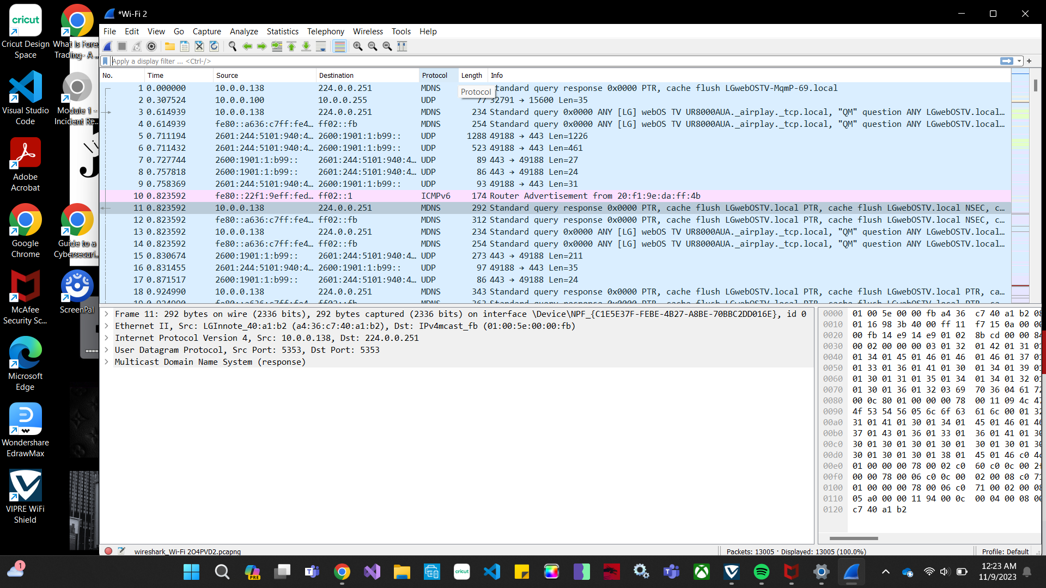
5.When I visited a secure website I was still shock with the amount of information I was still able to access but satisfied in the ability to see that some information about the packets being requested and in transit was returned to be encrypted as seen below. What I didn’t like was I still was able to view the port numbers that these conversations were being accessed and sent through. 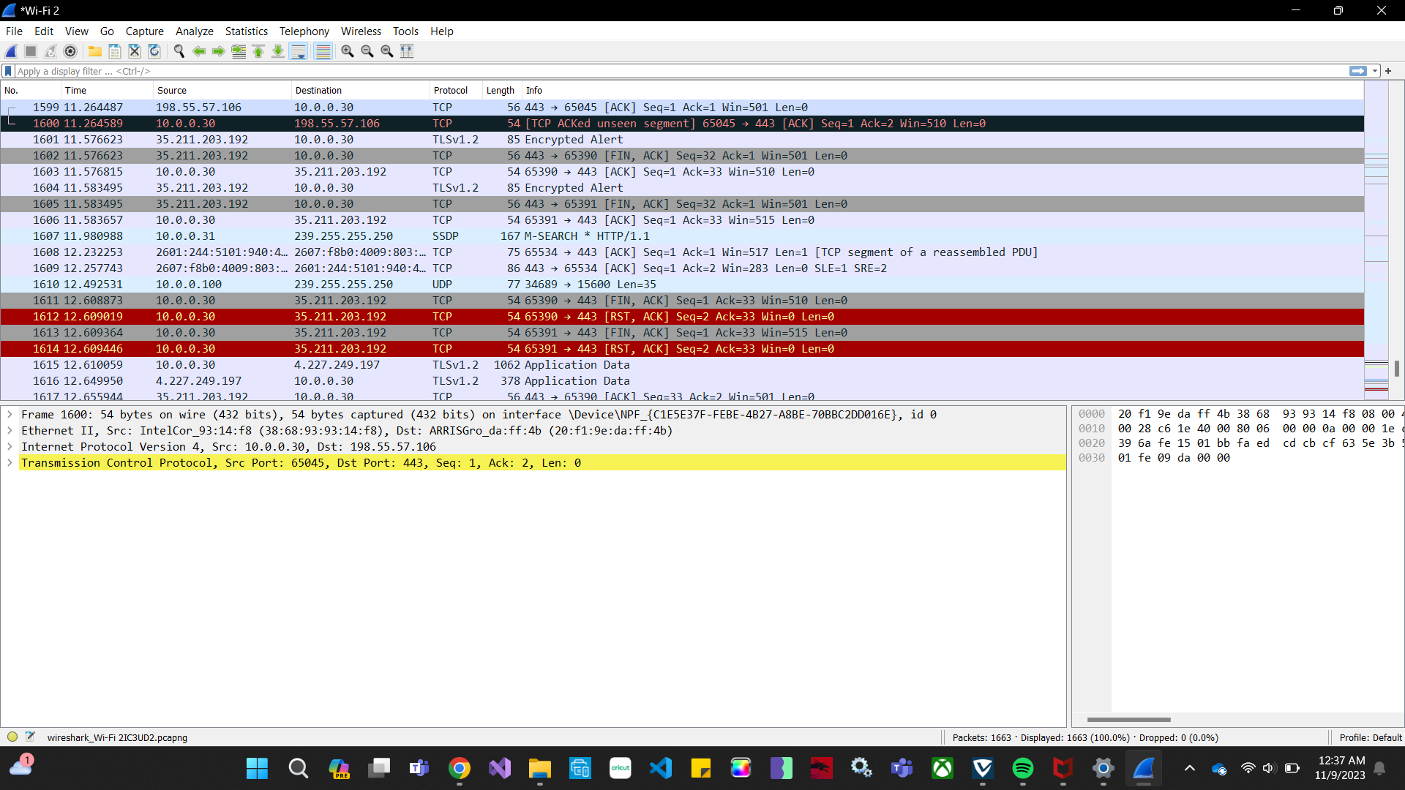
6.At my personal network I gained some confidence back in seeing that even with inspection of expert information with the analysis tools that the encryption does protect packet information. Though Wireshark isn’t the most advanced in decryption technology, knowing that it was unable to decrypt some of the packets was reassuring that not all of my data while browsing the web is available to be viewed.
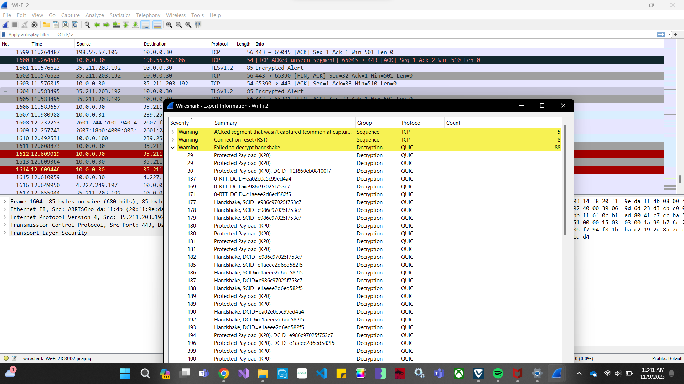

7.Unlike my personal network, I was able to mainly see the conversation between my laptop and the Starbucks router with a few side requests. I was unpleased to see that nothing was encrypted so i washable able to see alot of details about my computer and the information it was requesting. I wondered if this had to deal with the fact that it was my computer or if anyone else was able to view this information. What I also was disappointed in yet impressed was that I was unable to track any IP addresses that were not mine even though there were at least two other customers sitting down using their personal laptops in the Starbucks as well. (Granted I did not shoulder surf so I was not able to determine if they were even utilizing the Starbucks public Wi-Fi.) But an interesting point is, I was able to see the information about the CISCO system that Starbucks uses and the type of network that they utilize which is some basic yet foundational recon information if someone wanted to potentially take advantage of a public network such as that specific Starbucks location.
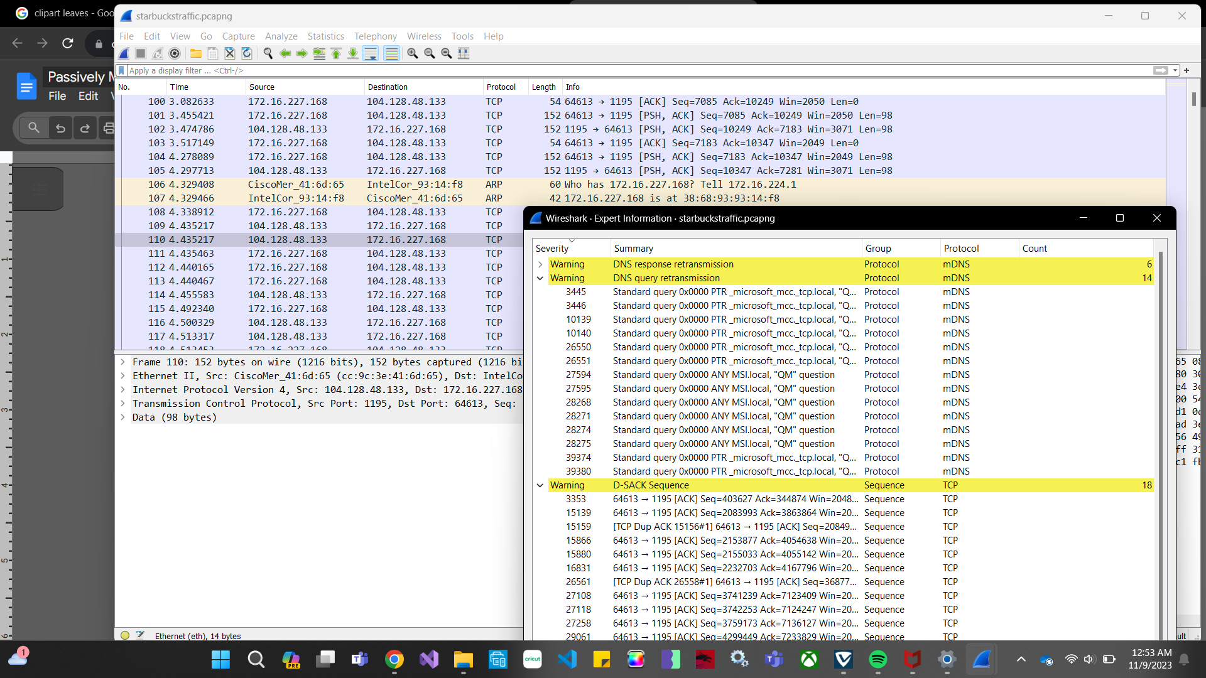
Part 2:
After using the packet analysis tools in Wireshark, I noticed two major differences between a personal/private network and a public network that I wasn’t expecting. The first was that on a personal network I am able to see other devices more clearly that are accessing the same Wi-Fi services as my laptop. This was shocking to me because I assumed that a private network was just that- more private. Whereas the public network makes more effort for me to just see the conversation between my personal client device (laptop) and the Starbucks network services. But I did notice that encryption was a bigger theme within my personal network even if I visited similar sites in comparison when I used the public network.
From my experience in the Starbucks network, I do think that the data seems to be somewhat secure considering I couldn’t view anyone else’s device activity aside from the routers and devices that provided me with the services. But that being said if a malicious actor was able to access or pretend to be another user, they would be able to view payloads or some form of data in transit depending on the sites. So yes I do believe that it is confidential, provides integrity and availability to a point.
Some policy considerations that I would implement include but are not limited to the following: ensuring that all public network locations prohibit any rogue devices to be connected to a network, ensure that strong firewalls are implemented between wireless networks and the infrastructured, enforce that any default configurations or encryption keys are changed on wireless access points,Intrusion Detection Systems (IDS) are to be deployed for suspicious activity and wireless audit logs should be reviewed on a regular basis.
A common debate is how much monitoring is too much monitoring when the end goal of data security and privacy is to protect networks and the data of users who are connected to them? Starting with the basics to reduce the exposure and identification of personal wireless identifiers, never neglect the usage of encryption of WPA2 standard or higher. Never ever share wireless network from your home unless absolutely necessary and if you need to- edit the filter for only specific MAC addresses to have access which will also reduce the risk of piggybacking.Change you SSID from the default that was provided with your router, this will also prevent unauthorized users from accessing your network.

